Fitness dla dzieci

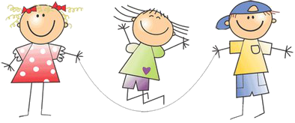

https://www.youtube.com/watch?v=43pgc7v6_2o
https://www.youtube.com/watch?v=RCgtcEz6SGk
https://www.youtube.com/watch?v=vK3x7muyTlc&list=PLQ9Py3ytnbSY7sJjKro3huOyIdRaIyDS1&index=7
https://www.youtube.com/watch?v=m-13-WFz7K8

Miłej zabawy!

Anetta Kruszka

